Project Design Phase-II
Data Flow Diagram & User Stories

Date | 20 February 2026
Team ID | LTVIP2026TMIDS82947
Project Name | ShopSmart
Maximum Marks | 4 Marks

Data Flow Diagrams:
A Data Flow Diagram (DFD) is a graphical tool that helps visualize how data moves through the ShopSmart system. It represents the flow of information between different modules like user interface, backend services, database, and admin portal. DFDs are essential for understanding system functionality at a glance and ensuring clear communication between developers and stakeholders.
Example Structure in ShopSmart:
- Users (customers/admins) send requests (login, browse, add to cart, etc.)
- Frontend captures input and communicates with backend via APIs
- Backend handles authentication, product logic, order placement, and admin control
- Database (MongoDB) stores user data, product listings, orders, cart, and feedback
- Admin Portal retrieves/manages data from the backend for inventory and order handling

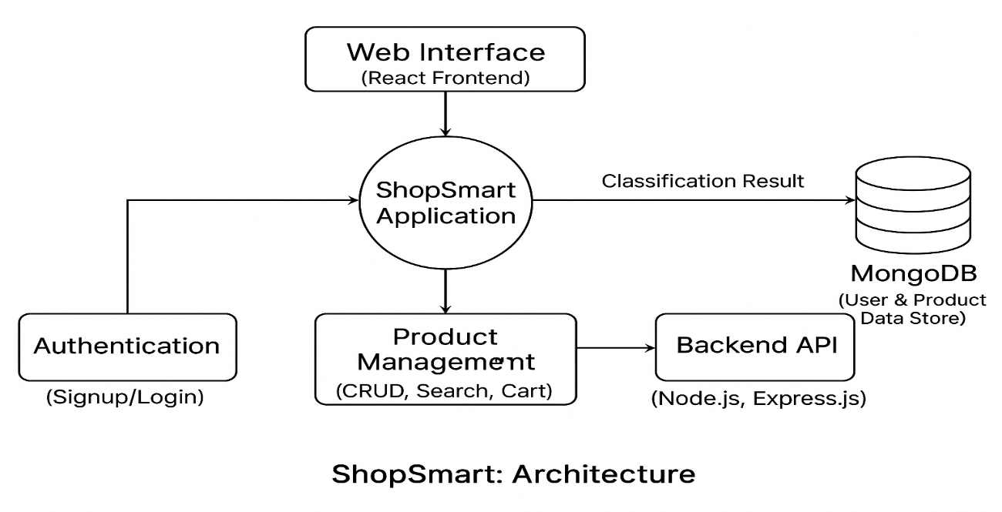

User Stories
Sprint | Functional Requirement (Epic) | User Story Number | User Story / Task | Story Points | Priority | Team Members
Sprint-1 | User Registration & Authentication | USN-1 | As a user, I can register and log in securely using JWT for protected access. | 3 | High | Likhitha Setty
Sprint-1 | Product Catalog | USN-2 | As a user, I can browse products with name, image, price, and category tags. | 3 | High | Sandu Raghuram Manikanta
Sprint-1 | Search & Filter | USN-3 | As a user, I can search and filter products by category or price. | 4 | High | Vadlamudi Tharun
Sprint-2 | Cart Functionality | USN-4 | As a user, I can add, remove, and update items in the shopping cart. | 3 | High | Paidimala Lokesh
Sprint-2 | Order Placement | USN-5 |  | 4 | Medium | Sandu Raghuram Manikanta
  As a user, I can place an order and receive a confirmation once it's placed.
Sprint-2 | Payment Integration | USN-6 | As a user, I can make online payments via Razorpay or UPI. | 5 | High | Paidimala Lokesh
Sprint-3 | Order Tracking | USN-7 | As a user, I can view my order history and track order status. | 2 | Medium | Likhitha Setty
Sprint-3 | Admin Dashboard | USN-8 | As an admin, I can add/edit/delete products and manage orders and feedback. | 4 | High | Sandu Raghuram Manikanta
Sprint-3 | Product Recommendations  (Future Scope) | USN-9 | As a user, I can get product suggestions based on my interests and past behavior. | 3 | Low | Vadlamudi Tharun
Sprint-3 | Final Testing & Deployment | USN-10 | As a team, we want to test all modules and deploy the working app to production. | 3 | High | All Members

